**Boiling Temperature at Different Atmospheric Pressures**

Mingchen Mao

**Objective:**

Find out the principles behind some boiling point calculators online.

**Introduction:**

The boiling temperature of a liquid is the temperature at which the vapor pressure of the liquid equals to the external environmental pressure surrounding the liquid. Once the vapor pressure in the bubbles of the liquid matches or even exceeds the external environmental pressure, these bubbles start to break through the atmospheric pressure barrier and rise up to the surface, this phenomenon is called boiling1.

In other words, investigating how the boiling temperature changes at different atmospheric pressures is to determine the relationship between temperature and vapor pressure.

**Methods:**

The Gibbs free energy is a quantity that is used to calculate the maximum or reversible work that may be performed by a thermodynamic system2. Which is defined as:

$$G=H-TS$$

Where G is the sign for Gibbs free energy, H is enthalpy, T is temperature and S is entropy.

Differentiating the equation above:

|  |  |  |
| --- | --- | --- |
|  | $$dG=dH-TdS-SdT$$ | (1) |

Recalling from the first law of thermodynamics:

$$dU=dQ-dW$$

$$dH-PdV-VdP=TdS-PdV$$

|  |  |  |
| --- | --- | --- |
|  | $$dH-TdS=VdP$$ | (2) |

Plugging (2) into (1):

|  |  |  |
| --- | --- | --- |
|  | $$dG=VdP-SdT$$ | (3) |

For a system at equilibrium, it always has a zero change in Gibbs free energy3, namely:

$$dG=0$$

As a result, for two different phases in one system at equilibrium, they should have the same change of the Gibbs free energy.

$$dG_{1}=dG_{2}=0$$

Substituting equation 3:

$$V_{1}dP-S_{1}dT=V_{2}dP-S_{2}dT=0$$

$$\left(V_{1}-V_{2}\right)dP=\left(S_{1}-S_{2}\right)dT=0$$

|  |  |  |
| --- | --- | --- |
|  | $$\frac{dP}{dT}=\frac{∆S}{∆V}$$ | (4) |

Since the Gibbs free energy does not change between these two phases, combing with the definition of Gibbs free energy:

$$∆G=∆H-T∆S=0$$

|  |  |  |
| --- | --- | --- |
|  | $$∆S=\frac{∆H}{T}$$ | (5) |

Substituting (5) into (4):

$$\frac{dP}{dT}=\frac{\frac{∆H}{T}}{∆V}$$

|  |  |  |
| --- | --- | --- |
|  | $$dP=\frac{∆H}{∆V}\frac{dT}{T}$$ | (6) |

Since vapor is concerned in this case, ideal gas should be reasonable to apply here. Then the change of volume in (6) can be expressed as:

$$∆V=\frac{nRT}{P}$$

So,

$$\frac{dP}{P}=\frac{∆H}{nR}\frac{dT}{T^{2}}$$

Integrating both sides:

|  |  |  |
| --- | --- | --- |
|  | $$lnP_{2}-lnP_{1}=\frac{∆H}{nR}\left(\frac{1}{T_{1}}-\frac{1}{T_{2}}\right)$$ | (7) |

Assuming everything is molar based, namely n can be assumed to be 1. Then rearranging (7):

|  |  |  |
| --- | --- | --- |
|  | $$T_{2}=\frac{1}{\frac{1}{T_{1}}+\frac{R}{∆H}\ln\left(\frac{P_{1}}{P_{2}}\right)}$$ | (8) |

Where:

T1 is the boiling temperature at atmospheric pressure, $T_{1}=100 ℃=373.15 K$

R is the molar gas constant, $R=8.3145 J/(K∙mol)$

$∆H$ is the heat of vaporization of water4,

P1 is atmospheric pressure, $P_{1}=101325 Pa$

Thus, the boiling temperature of water can be calculated as any given atmospheric pressure using the equation below.

|  |  |  |
| --- | --- | --- |
|  | $$T_{2}=\left(\frac{1}{\frac{20}{7463}+0.0002045\ln\left(\frac{101325}{P_{2}}\right)}-273.15\right) ℃$$ | (9) |

Where P2 is in Pascals.

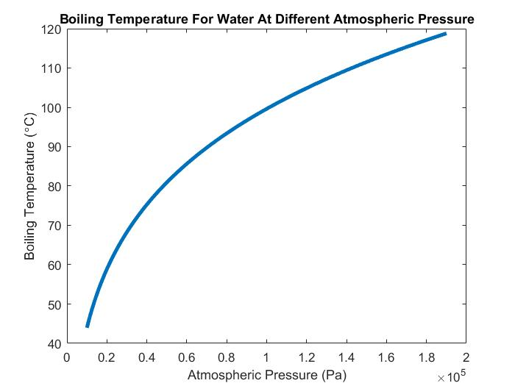

As the plot indicates, the boiling temperature decreases as the atmospheric pressure increases. However, at very high and low atmospheric pressure, the internal structure of water molecules may be different with the one in common condition. As a result, the curve above may be inaccurate at extremities.

**Tests**

For water at 0.9 atm,

$$T=\left(\frac{1}{\frac{20}{7463}+0.0002045\ln\left(\frac{101325}{0.9×101325}\right)}-273.15\right)=97.0233 ℃$$

The result is consistent with the one from <http://www.trimen.pl/witek/calculators/wrzenie.html>

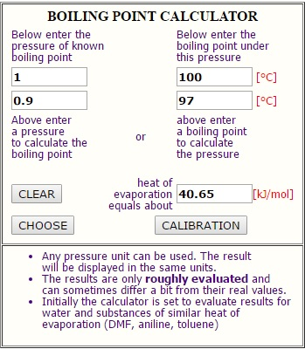

If the atmospheric pressure is 99999 Pa,

$$T=\left(\frac{1}{\frac{20}{7463}+0.0002045\ln\left(\frac{101325}{99999}\right)}-273.15\right)=99.6252 ℃$$

This boiling temperature is very close to the one obtained from <http://www.calctool.org/CALC/chem/substance/boiling>

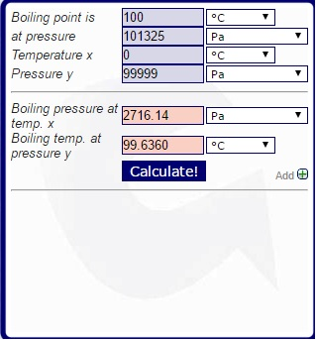

Conclusion

Equation 9 is reasonable to use to estimate the boiling temperature for water under different atmospheric pressure.

**Citations**

1. "Saturated Vapor Pressure." Vapor Pressure. Web. 24 May 2016.
2. "Gibbs Free Energy." Wikipedia. Wikimedia Foundation. Web. 24 May 2016.
3. "Free Energy The Reason Why a Reaction Occurs." Free Energy The Reason Why a Reaction Occurs. Web. 24 May 2016.
4. "Enthalpy of Vaporization." Wikipedia. Wikimedia Foundation. Web. 24 May 2016.

"CalcTool: Boiling Points Calculator." CalcTool: Boiling Points Calculator. Web. 24 May 2016.

"Boiling Point Calculator." Boiling Point Calculator. Web. 24 May 2016.

Borgnakke, C., and Richard Edwin. Sonntag. Fundamentals of Thermodynamics. Print.

<https://www.wunderground.com/resources/pressure_records.asp>

**Appendix**

clear all; close all;

T1=373.15; % K

R=8.3145; % J/K*mol

deltaH=40650; % J/mol

P1=101325; % Pa

P2=10000:0.1:190000;

T2=1./(1/T1+R./deltaH.*log(P1./P2))-273.15;

plot(P2,T2,'linewidth',3)

xlabel('Atmospheric Pressure (Pa)');

ylabel('Boiling Temperature (\circC)');

title('Boiling Temperature For Water At Different Atmospheric Pressure');